Project 6: File System Manager

CST-315 Operating Systems

Angel Velazquez, Nathan Dilla

April 14, 2024

In this project, we avoided using if statements to invoke commands. Instead, we tokenize the input into a C-style string sent to the executeCommand function. The program continuously prompts the user for input and utilizes the fork command to create child processes that wait for the parent process to finish executing.

The screenshot below shows the algorithm used to execute the shell commands.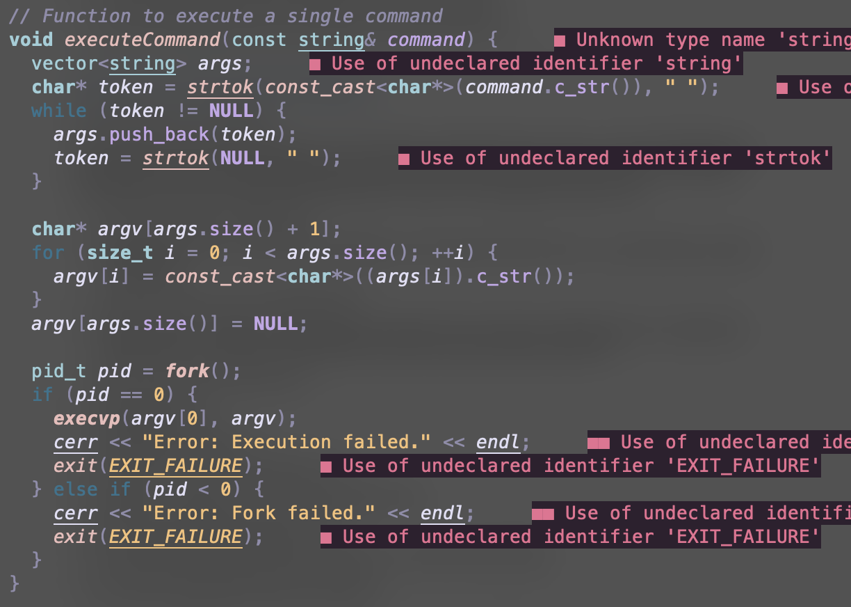

**Prompt the user for an input command.**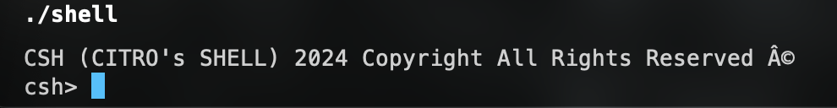

The shell name Citro’s shell (csh) is used for this project.

**Create a child process (use execv() and fork()).**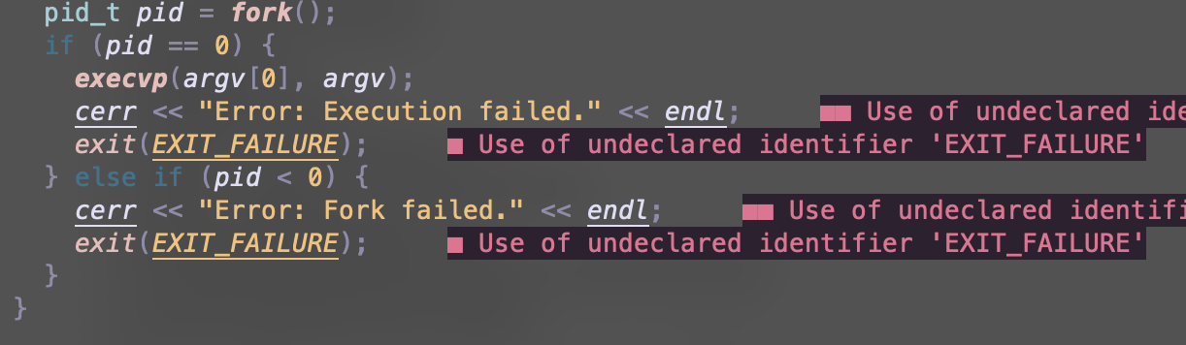

In the screenshot below, you can see the commands implemented into the shell. We test mkdir to create directories, mv to rename directories and files, rm to remove files and directories, touch to create files, vim to edit files, ls with an -l flag to print miscellaneous data, cp to move and copy files and directories, and find to search for files. Two screenshots of the vim homepage are implemented to show that the vim command works in the shell. The second screenshot below is the vim homepage ran on the shell. It does not support syntax highlighting. However, the third screenshot does have syntax highlighting, because it is running on the system’s native shell.

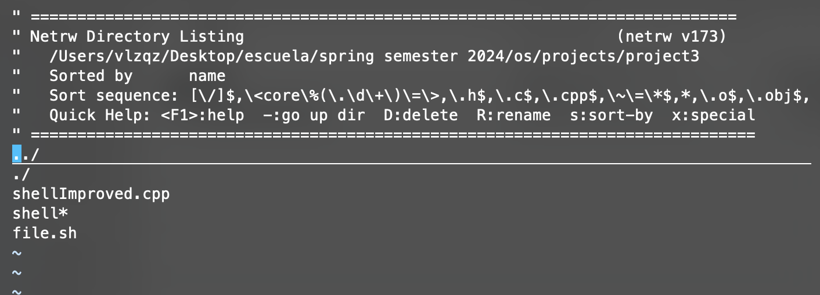: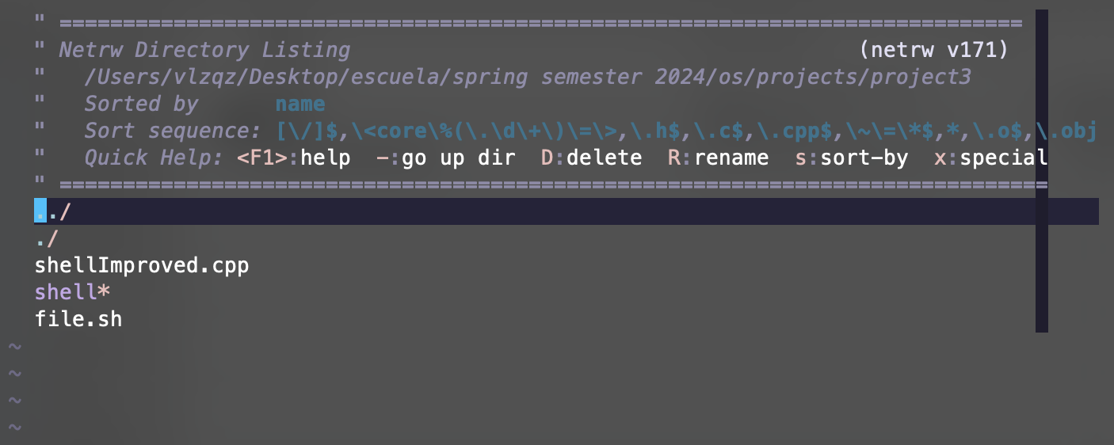

**Creating and renaming directories**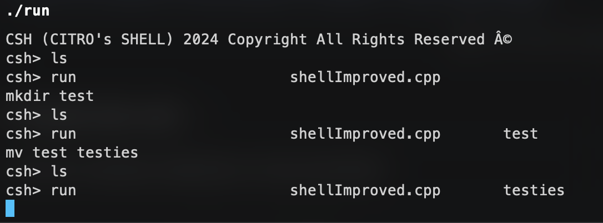

**Create, rename, edit, and delete files**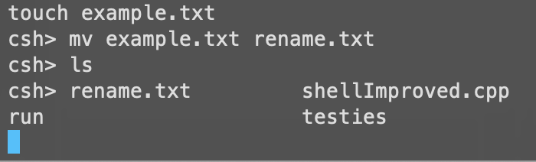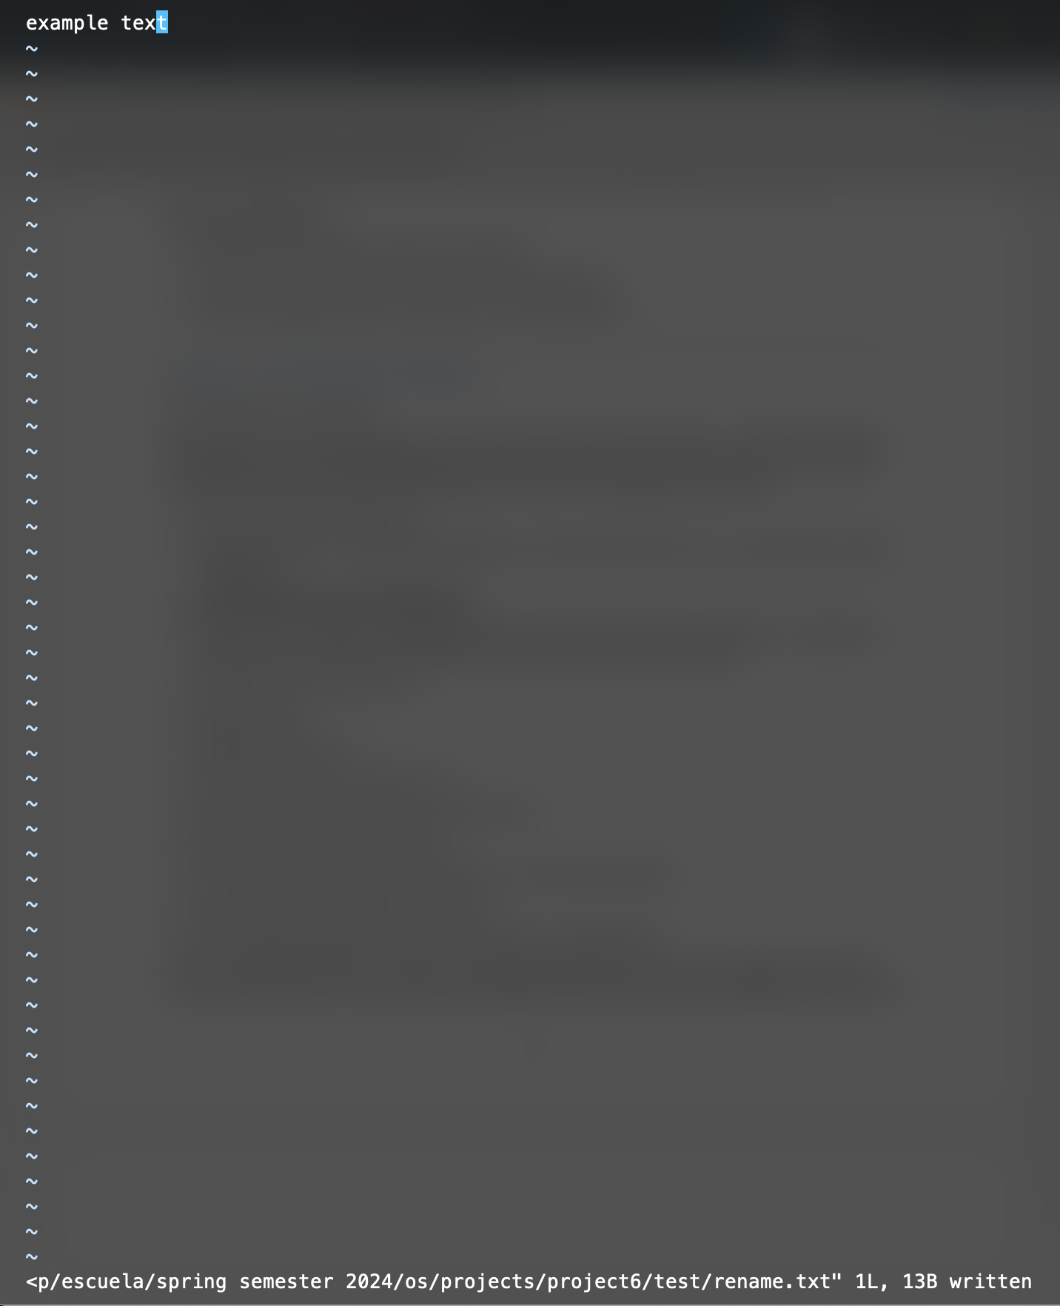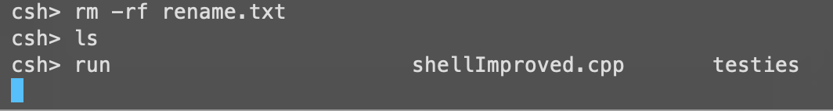

**When a file is created, a special flag indicates the amount of data in order to eliminate the need to open and edit each file**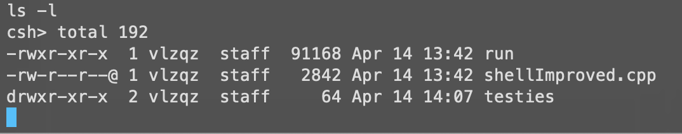

**Move files across direcories**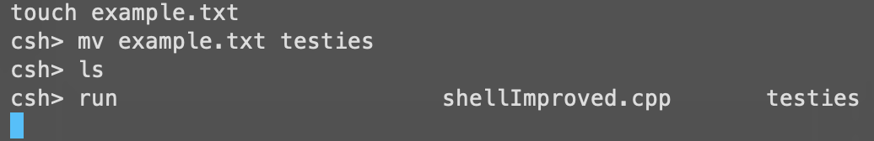

**Duplicate files**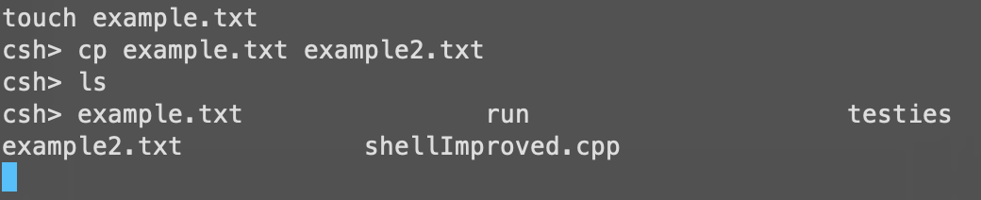

**lsDuplicate directories**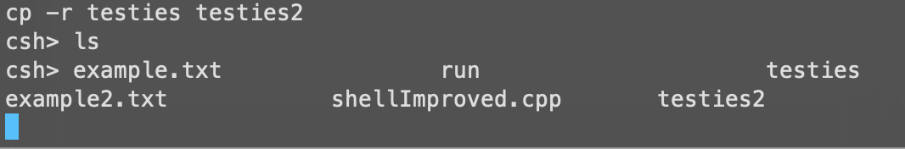

**Search for a file in a directory tree**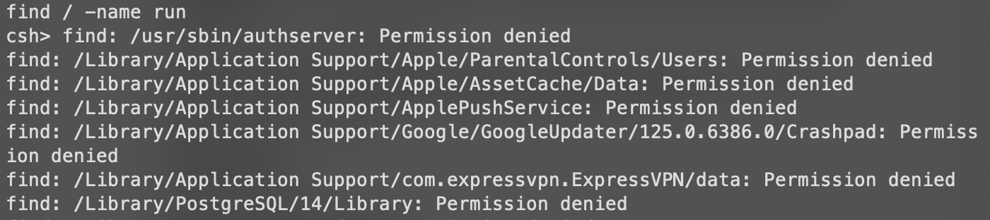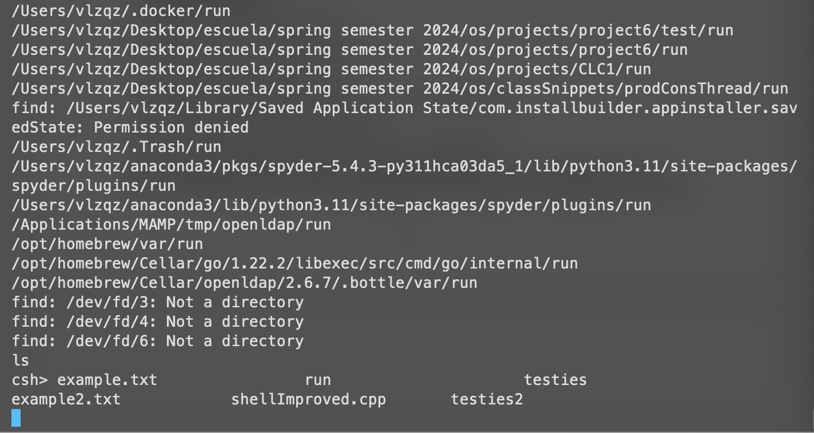

**Display a directory tree given a starting node**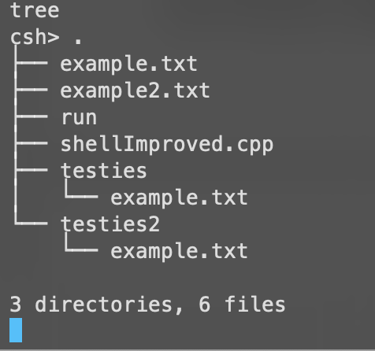

**Show execution of the exit command**

In the screenshot below, you can see that I simply enter ‘exit’ to quit the bash and return to the systems CLI

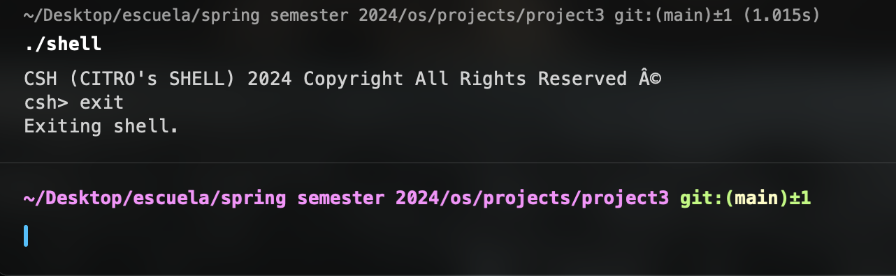

**Github Repo:** [Click Here](https://github.com/angel-vlzqz/Operating-Systems/tree/main/projects/project6)